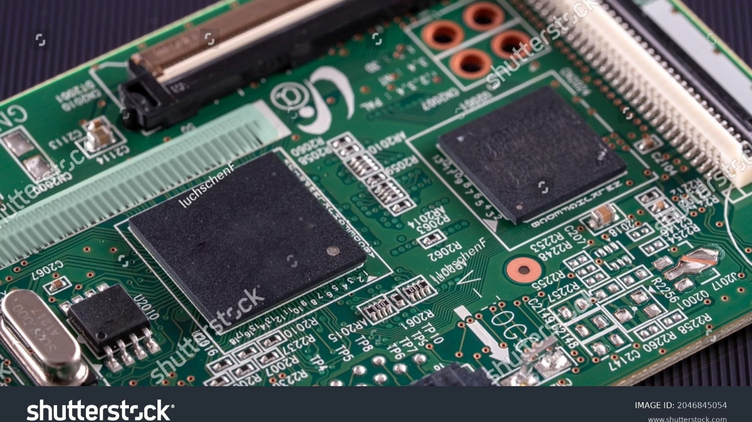
Task Priority in FreeRTOS
A deep-dive into how FreeRTOS schedules tasks based on priority, how the preemptive scheduler selects which task
runs, and what happens when two tasks compete for CPU time. Designed for embedded systems engineers and
firmware developers ready to master real-time task management.
FREERTOS
RTOS INTERNALS
TASK SCHEDULING
Aim — Analyse Priority Effect
This document investigates how task priority assignments directly influence execution order, CPU allocation, and

system responsiveness in a FreeRTOS environment. By observing a controlled two-task system, we establish a clear

understanding of priority-driven scheduling behaviour.
Core Question
What happens when two tasks

with different priorities are

created and allowed to run

simultaneously?
Expected Insight
The higher-priority task should

always preempt or block the

lower-priority task from executing

until it yields or blocks.
Practical Value
Understanding this behaviour is

critical for designing

deterministic, real-time

embedded applications with tight

timing constraints.
Scheduler Basics
FreeRTOS uses a
tick-based preemptive scheduler
that runs at a configurable frequency (typically 1 kHz). At each tick

interrupt, the scheduler evaluates which task has the highest priority in the Ready state and switches context if

necessary.
Scheduler Modes
Preemptive:
Higher-priority tasks immediately

preempt lower ones
Co-operative:
Tasks yield voluntarily; no forced

context switch
Time-sliced:
Equal-priority tasks share CPU in

round-robin fashion
Key Scheduler Concepts
Tick Interrupt:
Heartbeat driving the scheduler
Context Switch:
Saving and restoring task register

state
Ready Queue:
Sorted list of tasks eligible to run
Idle Task:
Lowest-priority task, always ready to run

Priority-Based Execution
In FreeRTOS, every task is assigned a numeric priority at creation.
Higher numbers indicate higher priority.
The

scheduler always selects the highest-priority task in the Ready state. A lower-priority task only runs when all higher-
priority tasks are Blocked, Suspended, or Deleted.
Low & Idle Tasks
Priority 1/0 — run when

higher idle
High Priority Task
Priority 2 — preempts

lower tasks
Critical ISR Deferred
Priority 3 — top CPU

preference
Priority starvation is a real risk — if a high-priority task never blocks, lower-priority tasks are permanently denied CPU

time. Good RTOS design ensures tasks block on queues, semaphores, or delays to relinquish control periodically.


Two-Task System
The canonical FreeRTOS priority experiment creates exactly two tasks — one at a higher priority, one at a lower priority —
and observes their execution interleaving via UART output or GPIO toggles.
Task A — High Priority (2)
Prints a message repeatedly. Because it holds the higher
priority, it dominates CPU time. It must call
vTaskDelay()
to
allow Task B any runtime.
Task B — Low Priority (1)
Prints an alternating message. Executes only during the
window when Task A is in the Blocked state waiting for its
delay period to expire.
Both tasks are created before
vTaskStartScheduler()
is called. The scheduler then takes full control of execution
order based solely on priority and task state.

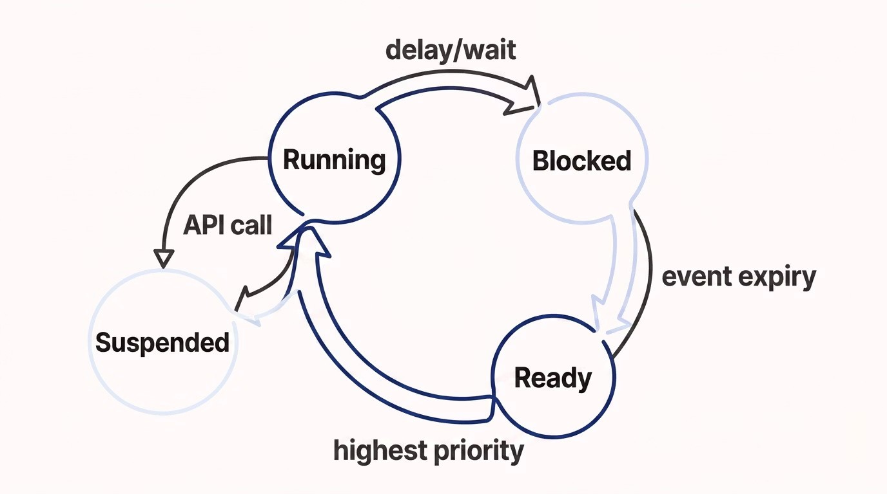
Working Mechanism
Understanding the state machine governing each FreeRTOS task is essential to predicting execution behaviour. Tasks
transition between four core states driven by API calls and scheduler decisions.
The critical path for our two-task experiment: Task A runs
→
calls
vTaskDelay()

→
moves to Blocked
→
Task B promoted to
Running
→
Task A delay expires
→
Task B preempted
→
Task A resumes Running.

Implementation Steps
Follow these steps to reproduce the priority experiment on any FreeRTOS-supported target (STM32, ESP32, Arduino

with FreeRTOS port, etc.).
1
Configure FreeRTOSConfig.h
Set
configUSE_PREEMPTION 1
, define
configTICK_RATE_HZ
(1000 recommended), and set
configMAX_PRIORITIES
to at least 5.
2
Create Task Functions
Write
vTaskA()
and
vTaskB()
as infinite loops. Include a
vTaskDelay(pdMS_TO_TICKS(500))
inside Task A to yield

periodically.
3
Register Tasks via xTaskCreate()
Call
xTaskCreate(vTaskA, "TaskA", 128, NULL, 2, NULL)
and

xTaskCreate(vTaskB, "TaskB", 128, NULL, 1, NULL)
before

starting the scheduler.
4
Start the Scheduler
Call
vTaskStartScheduler()
. Control never returns to
main()
. Monitor output via UART or a logic analyser on

a GPIO toggle pin.
Stack size (128 words here) must be sufficient for each task's local variables and function call depth. Increase if

stack overflow faults occur.

Output Behaviour
With preemption enabled and Task A calling
vTaskDelay(500 ms)
, the UART terminal produces a predictable, alternating

pattern that confirms the scheduler is operating correctly.
Expected UART Output
Task

A
:

Running
(High Priority)
Task

B

:
Running
(Low Priority)
Task

B
:

Running
(Low Priority)
Task

B
:

Running
(Low Priority)
Task

A

:
Running
(High Priority)
Task

B

:
Running
(Low Priority)
...
Task B may execute multiple iterations during Task A's 500 ms

block window depending on Task B's own loop timing and delay

configuration.
Timing Breakdown
:
0
–500 ms
Task A executes, then blocks
:
–500 ms
0
Task B runs during A's block
:
ms
500
Task A wakes, immediately preempts

B
Repeats
every scheduler tick cycle
Observations
Running this experiment yields several foundational insights about FreeRTOS scheduling that apply to all real-world

embedded designs.
Priority Is Absolute (Not Time-Sliced)
Without
vTaskDelay()
in Task A, Task B receives zero

CPU time. Priority preemption is not weighted — it is

binary: highest ready task runs exclusively.
Blocking Is the Yield Mechanism
The only way a high-priority task yields CPU is by

entering the Blocked state via delays, semaphores,

queues, or event groups. Busy-wait loops starve the

system.
Determinism Is Preserved
The output pattern is completely reproducible across

runs. This determinism is the defining characteristic

of an RTOS and distinguishes it from a general-
purpose OS.
Idle Task Confirms Correct

Configuration
If the Idle task runs (observable via hook), it confirms

no runnable user tasks are present — a useful sanity

check during bringup and debugging sessions.
Conclusion
Task priority in FreeRTOS is the primary lever for controlling execution order and guaranteeing real-time

responsiveness. This experiment confirms that the preemptive scheduler is strict, deterministic, and fully governed by

priority assignment and task state transitions.
Assign Priorities

Deliberately
Match priority levels to timing

criticality — ISR-deferred tasks

highest, background housekeeping

lowest.
Always Block, Never Busy-
Wait
Use
vTaskDelay()
, semaphores, or

queues to yield CPU. Tight loops

will starve all lower-priority tasks

completely.
Validate With Real Output
Use UART logs or GPIO toggles

with a logic analyser to empirically

verify scheduling behaviour during

development and integration

testing.
Mastering FreeRTOS task priority is foundational to building reliable, deterministic firmware for any embedded

real-time application.

